When they had finished breakfast, Jesus said to Simon Peter, “Simon son of John, do you love me more than these?” He said to him, “Yes, Lord; you know that I love you.” Jesus said to him, “Feed my lambs.” - John 21:15
When the resurrected Jesus calls Peter over after breakfast and puts him in charge of the flock, it’s not because Peter’s trustworthy. The last time they were together, Peter denied even knowing Jesus. His track record wasn’t stellar before that. He shooed away the kids who came to see Jesus. He tried to walk on water and sank. He managed to get the Prince of Peace angry enough to call him Satan.
But in the end, Jesus trusts him. Or at least entrusts God’s work to him. Because, whatever has happened in the past, he wants Peter on his team. Because the only thing he or any of us have to lean on is the people around us. And maybe you don’t trust people because they’re trustworthy, sometimes if you take a chance on trusting them, they become trustworthy in the process.
God, trust me, that I can become trustworthy. Make me into someone others can lean on. – Vince Amlin

Global Ministries Prayer for Germany: God, when we follow your great commandment to love our neighbour as ourselves, we realise how much the current political changes and challenges in Germany affect us. So many people voted for the far-right political party, the (AfD). This party not only criticises us and church-state relations, but also what we stand for: a diverse, open, affirming, just and caring society for all who have lived in our country for generations or only a short time.
Help us find clear words and mindful expressions with which to speak about what we are committed to. Help us to continue the discussion and demonstrate through our actions, involvement, and example what the consequences of your commandment should be today and tomorrow. Let us translate into action and words the fact that your son excluded no one from the neighbourhood. We ask this in the name of your Son, who taught us to love. Amen

Susan G. Latourette, Pastor – 860-759-4231, pastorsuel@yahoo.com
Michael G. Noonan, Director of Music
Margaret Leonard, Christian Education Coordinator
Rosemary Kuemper, Church Secretary
Charlotte Melia, Sexton
Office hours: Monday –Thursday, 9AM - 1 PM

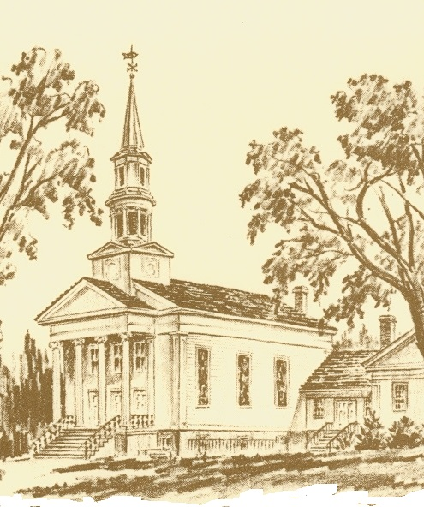

The Congregational Church
Of
North Stonington, U.C.C

89 Main Street
North Stonington, CT 06359
860-535-0379
NoStoUCC@comcast.net
www.northstoningtonucc.com

October 25, 2026
Reformation Sunday

23rd SUNDAY OF PENTECOST 10 a.m.

“As an Open and Affirming church:
We respect the worth and dignity of all persons who come into
our church family regardless of race, age, marital standing, gender identity or expression, economic status, mental or physical challenges, nationality or sexual orientation. We promise to support one another in our personal struggles, to understand and accept differences in one another, and pray to strengthen our love and acceptance.”

*indicates those who are able are invited to stand

WELCOME AND SHARING THE WORK OF THE CHURCH
Please come forward to use a microphone when you share.

PRELUDE “A Mighty Fortress” - Gordon Young

SILENT MEDITATION IN PREPARATION FOR WORSHIP

*CALL TO WORSHIP
We gather this morning for worship and company
on this journey of faith.
We come searching for meaning and hungry for peace.
We pray from personal longings and in care for all God’s
children; we share our hopes & doubts, offer gifts and
celebrate healing.
May we receive God’s unexpected blessings, exalt God’s holy name and taste God’s love!

*HYMN #25 O God Our Help in Ages Past St. Anne C.M.

*PRAYER OF INVOCATION AND LORD’S PRAYER (debts/debtors)
Healer, Savior, Still-Speaking God, hear our deepest pleas for insight. Speak to our need and faith. Do not leave us in our pews this morning but call us into following you down the roadway of the week to come, this we pray: Our Father...

*GLORIA PATRI (#759) Glory to the Creator, the Christ,
the Holy Spirit Three in One; As it was in the beginning,
Is now and ever shall be, world without end. Amen, amen.

*PASSING OF THE PEACE
May the peace of Christ be with you.
And also with you.
(We greet one another with a handshake of peace.)

Youth Choir Anthem
“Let All the World Sing Praise!” -Vicki Hancock Wright

TIME FOR CHILDREN
(The children are invited to attend church school.)

GENEROSITY MOMENT Amy Foster

SCRIPTURE LESSON (NT page 25) Matthew 22:34-46 (NT page203) 1 Thessalonians 2:1-8

CHOIR ANTHEM “Christ is Our Cornerstone” -Hal H. Hopson

SERMON “Harder to Love than to Hate”

MOMENTS OF SILENCE

*HYMN #388 Help Us Accept Each Other Aurelia

OFFERING OF OUR TITHES AND GIFTS
Place prayer requests in offering plates at this time

OFFERTORY “Amazing Grace” - setting by John Behnke

*DOXOLOGY (#780)
Praise God from Whom all blessings flow;
Praise God all creatures here below;
Praise God above, you heavenly host; Praise Father, Son and Holy Ghost. Amen.
*PRAYER OF DEDICATION

PRAYERS OF THE PEOPLE Response: Lord, hear our prayer

*HYMN #439 A Mighty Fortress Is Our God Ein Feste Burg
*BENEDICTION
POSTLUDE
“Toccata and Fugue in D minor” (Excerpt) – J. S. Bach (1685-1750)

Please exit quietly so those who wish to stay and listen may

Cameras are in use - We live-stream on Youtube and Facebook
Welcome to worship this morning. Guests are invited to sign our guest book in the entry or complete the welcome card in your pew. Please join us for Fair Trade Coffee in Hewitt Hall after worship. Church school is open to all and a nursery room is available.

We light one white candle each Sunday to remember and pray for military and civilians serving our country and in harm’s way.

We light one white candle each Sunday to remember and pray for military and civilians serving our country and in harm’s way. The sunflowers are a symbol of prayer for Ukraine.

The flowers are given to the glory of God.

Serving in Worship Ron Robbins, deacon; Matthew Sander, Steve Gadaree, ushers .

We Pray For: Stephanie and Doug Murray; George McCullen; John and Aggie Terrill; Kevin Ames; Rev. Lee Ireland; Amy Foster; Debbie Janda; Mike Baker; Sue Pianka; Mary Stilli (Elizabeth Witter’s daughter); Patty Danley; Robert Fox; Elizabeth Bouchard; Julie Evans; Marilyn Ware; Clare Whitney; Betsy Alvarez; Elizabeth Witter; Paul Ames; Dave McCord; Denise Hager; Nancy Rockwell; Mark Ball; and George Haimbach. Prayer requests remain for 6 weeks unless otherwise requested.

MISSION FOCUS FOR October: Neighbors In Need - United Church of Christ, supports ministries of justice and compassion, with one - third of the offering given to the Council for American Indian Ministries and the remaining two - thirds supporting UCC justice ministries.

Stewardship Reminders for 2026
Thank you for giving regularly this year.
You are so important to our Church Family!
Now, at year’s end, please don’t wait till December 31st to keep up with your pledges and offerings. Your support helps pay our bills and move into our new year smoothly. If you need to know your “balance”, your pledge payment or your member dues pledge, please call the Financial Secretary, Steve Weicksel. Thanks very much.
Thursday: Pie-assembly a.m. & p.m.
5:0 0-5:40 pm : Youth Choir
6:00-7:00 pm: Senior Choir
7:15-8:30 pm: Handbell Choir
November 10, 7 pm: Church Council
15, 11:30 am: Thankful Dinner
26th : Office closed in observance of Thanksgiving

Daylight Savings Time ends November 1, Turn clocks back Saturday

Senior Choir Anthem - - Hopson
Christ is our cornerstone,
On him alone, we build;
The one true head alone, the one our years have filled.
On his great love our hopes we place of present grace and joys above.

O then with hymns of praise
This hallowed hall shall ring;
Our voices, we will raise the Three in One to sing.
And thus proclaim in joyful song, both loud and long that glorious name.

Here, gracious God, do now and ever more draw near;
Accept each faithful vow, each fervent prayer now here.
Our spirits soar!
On all who pray this holy day, your blessings pour!

Here may we gain from the Thee,
The grace which we implore
And may that grace we see be with us evermore.
O blessed day when all the blest to endless rest are called away.

Jammie Grammy is collecting P.J.'s Begins November 8th to November 30th. Please bring in a few sets of new pajamas.
Any size: Babies and Toddlers, to size 16
Help us fill up the two boxes at church.
Thanks, from Grammie Jammie

All Hymns from the (NCH) New Century Hymnal; © 1995 The Pilgrim Press, have been granted permission for this one-time use. Permission to reprint, podcast, and / or stream the music in this service obtained from ONE LICENSE with license #735340-A. All rights reserved.

