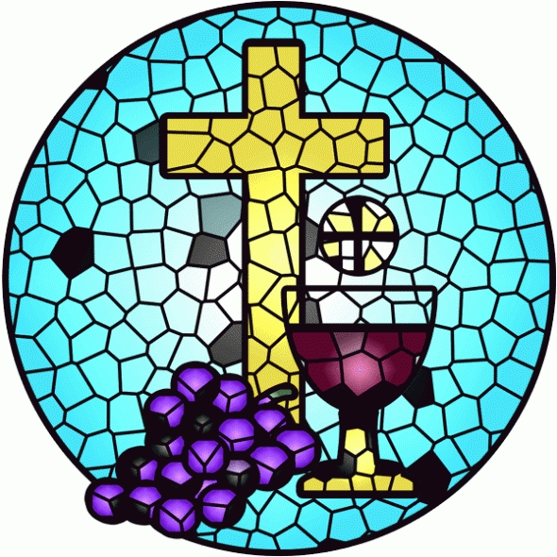

The Congregational Church
of
North Stonington, U.C.C.

89 Main Street
North Stonington, CT 06359
NoStoUCC@comcast.net
NoStoUCC.org

July 5, 2026
Communion

SIXTH SUNDAY OF PENTECOST 10 a.m.
“As an Open and Affirming church:
We respect the worth and dignity of all persons who come into our church family regardless of race, age, marital standing, gender identity and expression, economic status, mental or physical challenges, nationality or sexual orientation. We promise to support one another in our personal struggles, to understand and accept differences in one another, and pray to strengthen our love and acceptance.”

*indicates those who are able are invited to stand

WELCOME AND SHARING THE WORK OF THE CHURCH

Prelude “America the Beautiful” - Lani Smit

SILENT MEDITATION IN PREPARATION FOR WORSHIP

*Call to worship -Psalm 33:18-22
Truly God watches over all who look for guidance
and find hope in God’s steadfast love.
Our soul waits for our Redeemer who is our help and shield.
Trust in God brings gladness to our hearts.
And so, O God, let your steadfast love be upon us,
even as we hope in you.

*HYMN #8 Praise to the Living God Diademata

*Prayer of Invocation AND LORD’s prayer
This is the day you have made, O God. So we rejoice and are glad in it. We are grateful for this time that has come to us after 250 years of Independence. For those who came before us, we give you thanks. For the hard work of faith that yet remains to be done, we ask your help. Nourish us in spirit and body and mind, that we have the strength to walk in your Way and spread Good News. This we pray: Our Father . . .

*GLORIA PATRI (#759)
Glory to the Creator, the Christ, the Holy Spirit
Three in One; As it was in the beginning,
Is now and ever shall be, world without end. Amen, amen.

*PASSING OF THE PEACE (we offer a sign of Christ’s peace)
May the peace of Christ be with you.
And also with you.
Children are invited to attend church school & return for communion.

SCRIPTURE LESSONS (OT page 448) Esther 7:1-32
(NT page 58) Luke 1:68-72

SERMON “From Sadness to Joy”

MOMENTS OF SILENCE

*HYMN (insert) My Country, ‘Tis of Thee My Country, ‘Tis of Thee
Please hold up prayer requests for ushers to collect at this time.

PRAYERS OF INTERCESSION Response: Lord, hear our prayer

OFFERING OF OUR TITHES AND GIFTS
The bread and cup are part of what we offer

Offertory “Tribute to America” - arr. Mark Hayes

*DOXOLOGY (#780)
Praise God from Whom all blessings flow;
Praise God all creatures here below;
Praise God above, you heavenly host;
Creator, Christ, and Holy Ghost. Amen.

*PRAYER OF DEDICATION

SACRAMENT OF HOLY COMMUNION
UNISON PRAYER OF CONFESSION
Dear God, for the day you have given us, with all its possibilities, we give you thanks. For your gifts of life and love, labor and rest, hear our praise. Forgive us when we forget to be grateful; or if we despair thinking you are not with us. Help us to walk together in joy in all your ways. Hear now our own personal prayers . . .

PERSONAL CONFESSION
WORDS OF ASSURANCE
Be of good courage, for God sent the Word into the world not to judge, but to save. In the name of Jesus Christ our sin is forgiven.
Through the power of the Holy Spirit,
let us live as children of God. Amen
The Invitation
-Words of Institution
-The Prayer of Consecration
-The Distribution of the Elements
We receive the bread, hold it, and eat together
We receive the cup and drink as we receive.
Prayer of Thanksgiving
Holy Spirit, who in Christ rearranges what we think is solid, make of us to be your faithful followers whose lives
show forth your love. Gracious God, you give us your work to do in the world – send us out with the good news of your grace, and to demonstrate compassion and love in a world that is so in need of your peace. Amen

*HYMN (insert) America, The Beautiful America
*BENEDICTION

Postlude “Postlude on National Airs” - Charles Callahan

Please exit quietly so those who wish to stay and listen may

We live-stream on Youtube and Facebook: see nostoucc.org

Welcome! Thank you for worshiping with us today! All children are welcome to attend church school. Please join us for conversation and Fair-Trade Coffee after worship in Hewitt Hall. Please sign our guest book at the entryway or fill out a pew card so we can get to know you.

We light one white candle each Sunday to remember and pray for military and civilians serving our country and in harm’s way. The sunflowers are a symbol of prayer for Ukraine.

The flowers are given to the Glory of God by Julie Evans in honor of this great country.

Today’s music reflects the spirit of America as we celebrate our country’s 250th birthday.

Serving in Worship Matthew Sander, deacon, Gretchen Noonan, Kevin Noonan ushers; Gretchen Noonan, lay reader; Julie Clow, Kathi Thaxton, communion.

We Pray For: Stephanie and Doug Murray; George McCullen; Aggie Terrill; Kevin Ames; Rev. Lee Ireland; Amy Foster; Debbie Janda; Mike Baker; Sue Pianka; Mary Stilli (Elizabeth Witter’s daughter); Ray Wells; Patty Danley; Robert Fox; Elizabeth Bouchard; Julie Evans; Marilyn Ware; Clare Whitney; Betsy Alvarez; Elizabeth Witter; Paul Ames; and Dave McCord.
Prayer requests remain for 6 weeks unless otherwise requested.

Rosemary will be on vacation starting July 6 and returning to the
office on July 20.

July is Hunger Awareness month at the PNC ...
Help the PNC feed the people in our town. One focus is for “The Weekender Backpack Program” Children fill their backpacks every Friday – so please bring foods early in the week. Or use the green envelopes in the pews to make your donation. Your contribution will help purchase milk and food to help feed children and adults from North Stonington.

Summer Music Our choirs have earned a well-deserved break for the summer. During summer worship, we offer our “Summer Music” program. Anyone is invited to offer a song during summer worship. You do not need to be in choir to offer to sing or play. Just sign up on the summer music sign-up sheet in the choir room or see Mike.

CALENDAR
Thursday: Pie-assembly a.m. & p.m.

All Hymns from the (NCH) New Century Hymnal; © 1995 The Pilgrim Press, have been granted permission for this one-time use. Permission to reprint, podcast, and / or stream the music in this service obtained from ONE LICENSE with license #735340-A. All rights reserved.

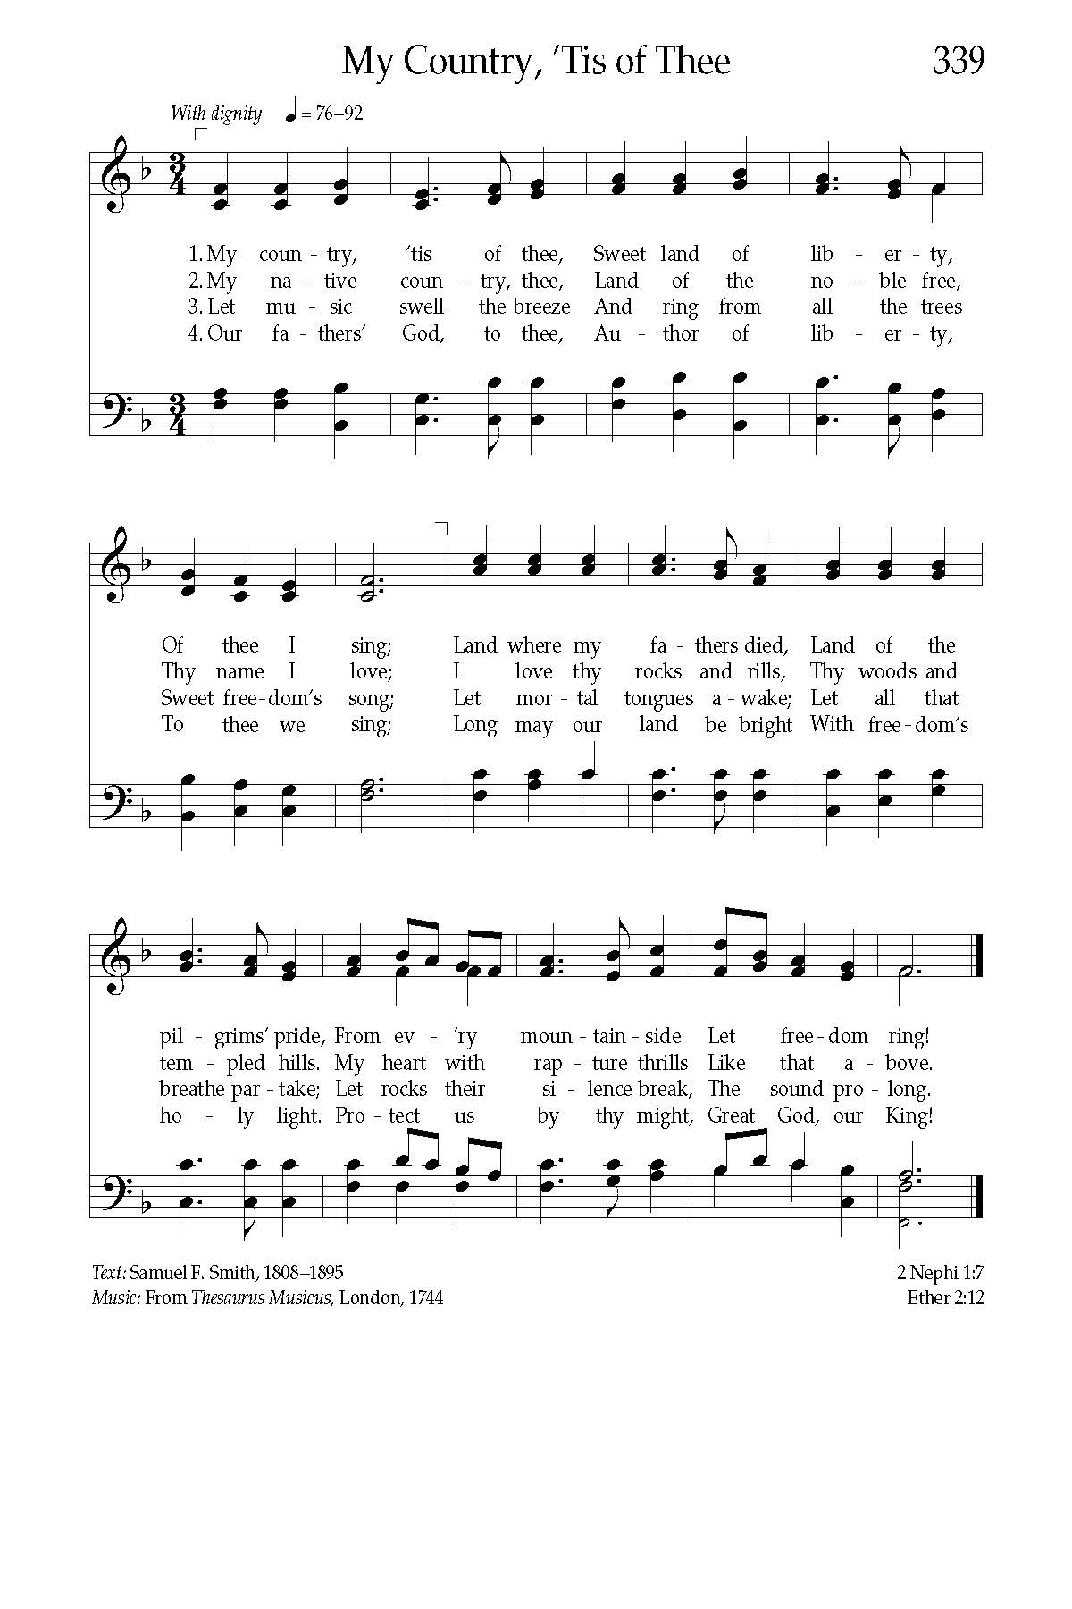

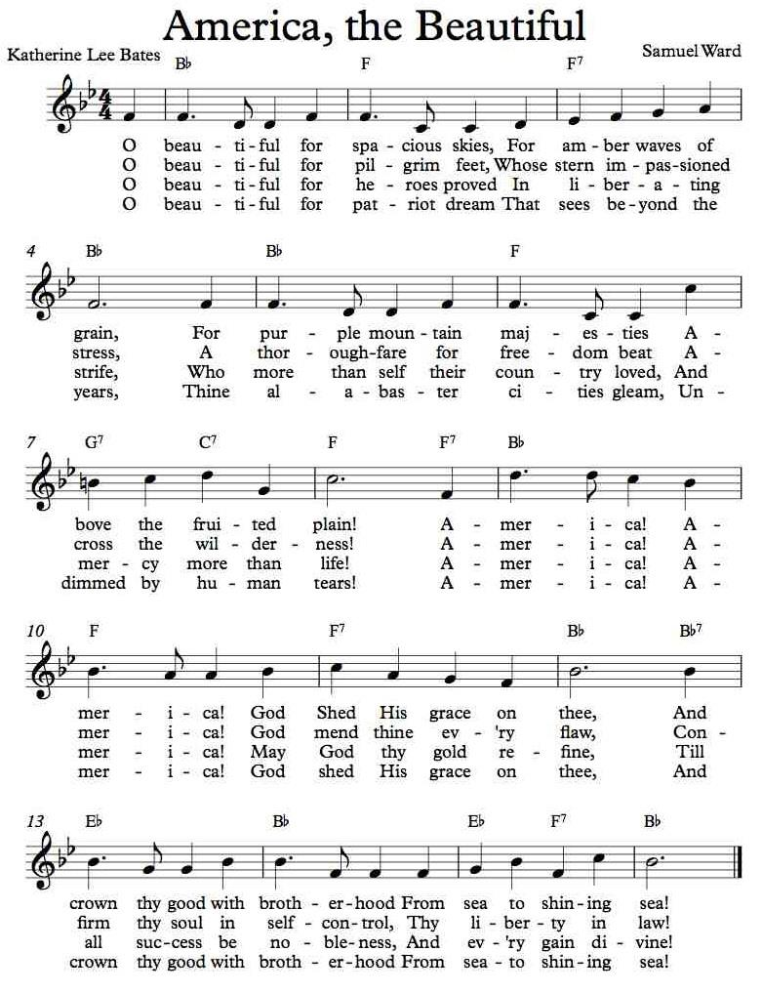

“For the Lord, the Most High, is awesome, a great king over all the earth.”
- Psalm 47:2 (NRSV)
Perhaps like you, I have difficulty with the Bible’s “kingly” language, whether for God or Jesus Christ. It’s even more problematic as Christian nationalists use “Christ is King” to exclude others from Divine grace.
So, I was tempted to forego today’s psalm. Then I recalled a talk with one of the saints of the UCC, the Rev. Dr. Reuben Sheares.
One day over lunch, I asked him. “I don’t understand,” I said, “what ‘Jesus is King’ means. Even more, I can’t understand how you as a strong, smart, wise Black man can worship this white guy Jesus.”
“First of all, Daughter,” Reuben said, “Jesus wasn’t white. Second, as a young Black man growing up in Jim Crow Charleston, professing that ‘Jesus is King’ meant that Lester Maddox, George Wallace, and all the rest weren’t. Not even the Grand Wizard of the Klan was king.”
“The only One worth worshipping . . .” Reuben continued, “was the One who lived his life for others, the One who gave his life for others. The One who assured me—and my family and my community—that we were people of worth and value, no matter what the world we lived in told us.”
“So, Daughter,” he concluded, “that’s what I mean when I say ‘Jesus is King.’ Now finish your sandwich. I need to get back to work.”
-Talitha Arnold
Global Ministries Prayers for Fiji - Thank you for the students in the Pasifika Philosophies program and the Pasifika Communities University. Reveal your wisdom through the knowledge, traditions, and experiences of Pacific peoples, and inspire new generations to treasure and carry them. Bless the faculty, staff, students, and community partners of PCU. Grant wisdom to those shaping this new university and courage to those working to build a future grounded in justice, dignity, and the flourishing of all life.
Strengthen the partnership between Global Ministries and PCU. May our shared witness continue to foster learning, friendship, and mutual transformation, so that together we may seek the well-being of communities and the fullness of life you desire for all people. Amen.

Our Ministers: the congregation
Susan G. Latourette, Pastor – 860-759-4231, pastorsuel@yahoo.com
Michael G. Noonan, Director of Music
Margaret Leonard, Christian Education Coordinator
Rosemary Kuemper, Church Secretary
Charlotte Melia, Sexton
Office hours: Monday –Thursday, 9am - 1 pm 860-535-0379

