

The Congregational Church
of

North Stonington, U.C.C.

89 Main Street
North Stonington, CT 06359
NoStoUCC@comcast.net
NoStoUCC.org

October 4, 2026
World Communion Sunday

NINETEENTH SUNDAY OF PENTECOST 10 a.m.
We respect the worth and dignity of all persons who come into our church family regardless of race, age, marital standing, gender identity and expression, economic status, mental or physical challenges, nationality or sexual orientation. We promise to support one another in our personal struggles, to understand and accept differences in one another, and pray to strengthen our love and acceptance.”

*indicates those who are able are invited to stand

WELCOME AND SHARING THE WORK OF THE CHURCH

Prelude “Voluntary” – Mozart

SILENT MEDITATION IN PREPARATION FOR WORSHIP

*CALL TO WORSHIP
O Lord, our God, how majestic is your name in all the earth!
We proclaim your name to the whole human family.
We praise you in the midst of this congregation:
O Lord, our God, how majestic is your name in all the earth!
Let us continue to praise our majestic Creator.

*HYMN #400 Christ Is Made the Sure Foundation Regent Square

*PRAYER OF INVOCATION AND LORD’S PRAYER (debts/debtors)
O God, our rock and our redeemer, enlighten us today through the ancient witness of your people. Remind us you seek to bring blessing to our life. We come this day to honor your name and keep this day of rest and worship. On this World Communion Sunday, remind us of our connection to all people across the globe. May our work and prayer be a blessing to others, near and far. We pray Jesus’ name, Our Father….

*GLORIA PATRI (#759)
Glory to the Creator, the Christ, the Holy Spirit
Three in One; As it was in the beginning,
Is now and ever shall be, world without end. Amen, amen.

*PASSING OF THE PEACE (we offer a sign of Christ’s peace)
May the peace of Christ be with you.
And also with you.
Children are invited to attend church school & return for communion.

SCRIPTURE LESSONS (OT page 634) Isaiah 5:1-7
(NT page 24) Matthew 21:33-46

CHOIR ANTHEM “Instrument of Peace” - Greg Gilpin

SERMON Sour Grapes

MOMENTS OF SILENCE

*HYMN insert One Bread, One Body One Bread, One Body
Please hold up Prayer Requests during hymn for ushers to collect

PRAYERS OF INTERCESSION Response: Lord, hear our prayer
OFFERING OF OUR TITHES AND GIFTS

Offertory “In Heavenly Love Abiding” - Wolford

*DOXOLOGY (#780)
Praise God from Whom all blessings flow;
Praise God all creatures here below;
Praise God above, you heavenly host;
Creator, Christ, and Holy Ghost. Amen.

*PRAYER OF DEDICATION

SACRAMENT OF HOLY COMMUNION

Responsive Prayer of Confession
Before God, with the people of God, I confess to turning away from God, in the ways I wound my life, the lives of others and the life of the world.
May God forgive you, Christ renew you, and the Spirit enable you to grow in love.
Amen.
Before God, with the people of God, we confess to turning away from God, in the ways we wound our lives, the lives of others and the life of the world.
May God forgive you, Christ renew you, and the Spirit enable you to grow in love.
Amen

-The Invitation
-Words of Institution
-The Prayer of Consecration
-The Distribution of the Elements
We receive the bread, hold it, and eat together
We receive the cup and drink as we receive.
Prayer of Thanksgiving
Majestic and eternal God, you have fed us with the bread of life and satisfied us with the cup of salvation. As we rise from this table, may we remember its expanse, and our connection to our siblings in Christ around the globe. Make us instruments of your peace and messengers of your love in thought, word, and deed. Make us one with you and all of creation through the power of the Holy Spirit. Amen.

*HYMN #28 For the Beauty of the Earth Dix
*BENEDICTION
POSTLUDE “Psalm 19 - The Heavens Declare” - Marcello

Please exit quietly so those who wish to stay and listen may

We live-stream on Youtube and Facebook: see nostoucc.org

Welcome! Thank you for worshiping with us today! All children are welcome to attend church school. Please join us for conversation and Fair-Trade Coffee after worship in Hewitt Hall. Please sign our guest book at the entryway or fill out a pew card so we can get to know you.

We light one white candle each Sunday to remember and pray for military and civilians serving our country and in harm’s way. The sunflowers are a symbol of prayer for Ukraine.

The flowers are given to the glory God for World Communion Sunday.

Serving in Worship Karen Dobley, deacon; Patty Danley, Monica Eppinger, ushers; Kathi Thaxton, Dave McCord, Communion; Gretchen Noonan, lay reader.

We Pray For: Stephanie and Doug Murray; George McCullen; John and Aggie Terrill; Kevin Ames; Rev. Lee Ireland; Amy Foster; Debbie Janda; Mike Baker; Sue Pianka; Mary Stilli (Elizabeth Witter’s daughter); Ray Wells; Patty Danley; Robert Fox; Elizabeth Bouchard; Julie Evans; Marilyn Ware; Clare Whitney; Betsy Alvarez; Elizabeth Witter; Paul Ames; Dave McCord; Denise Hager; Roseanne Sherman;
Nancy Rockwell; Mark Ball; and George Haimbach. Prayer requests remain for 6 weeks unless otherwise requested.

CALENDAR
Today after worship: Blessing of the Animals
Tuesday, 7 pm: Church Council
Thursday: Pie-assembly a.m. & p.m.
6:00-7:00 pm - Sr. Choir
7:15-8:30 PM: Handbell Choir

Coming events
October 11 Generosity Sunday
10 am: Alzheimer’s Walk see bulletin board for more information
13, 5 pm: Community German Dinner
18: Proposed Budget Meeting
1 pm: CROP HUNGER WALK, Mystic – Details in Hewitt Hall
“Instrument of Peace” by Greg Gilpin

Where there is hatred, let me so love.
Where there is injury, let there be pardon.
Where there is doubt, let there be faith.
Let me be an instrument of peace….

All Hymns from the (NCH) New Century Hymnal; © 1995 The Pilgrim Press, have been granted permission for this one-time use. Permission to reprint, podcast, and / or stream the music in this service obtained from ONE LICENSE with license #735340-A. All rights reserved. Call to Worship from Before the Amen, p 207, Invocation, p 101
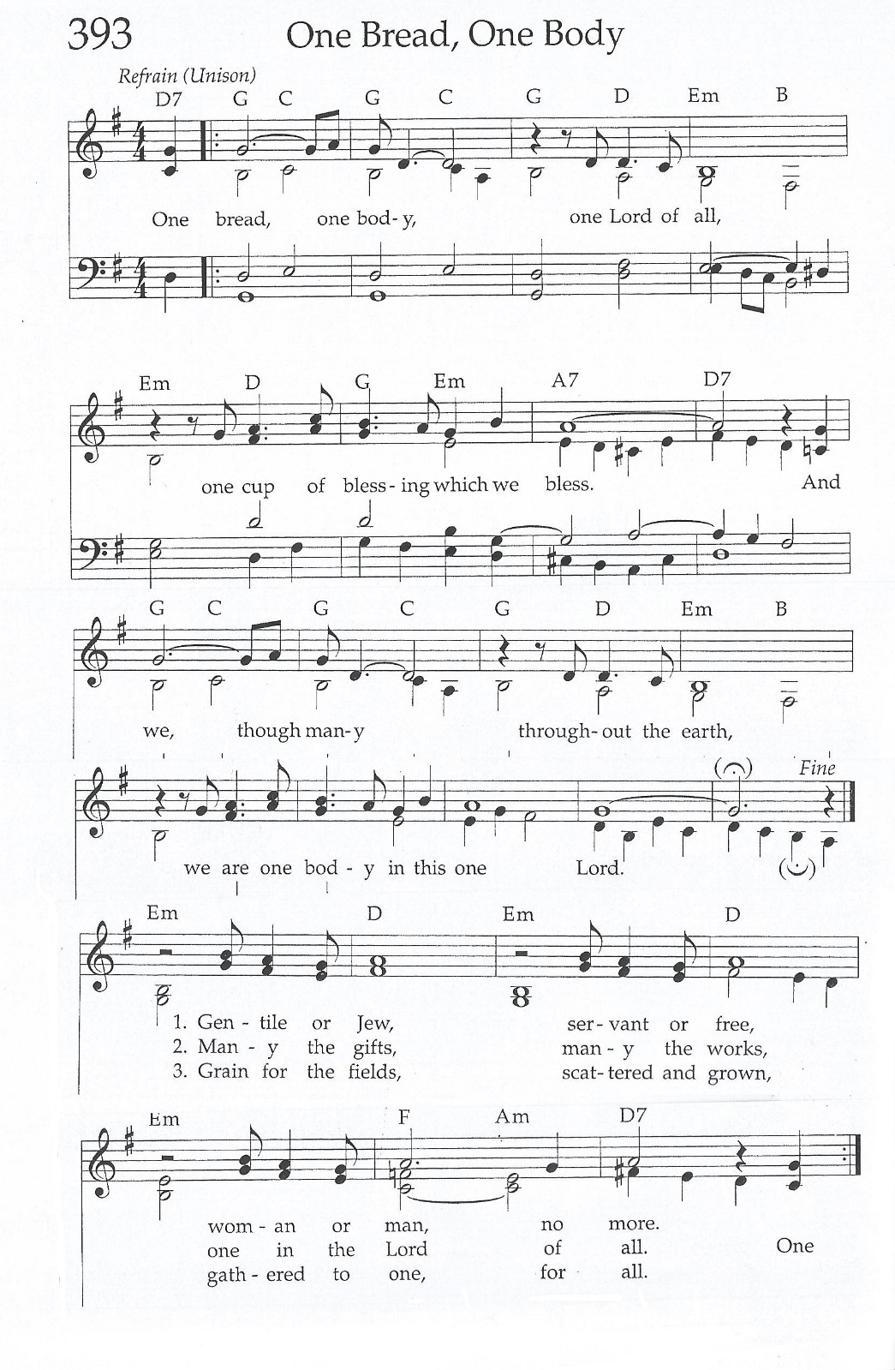

4 October 2026_____________________________ _Pentecost 19
“Therefore tell the people: This is what the Lord Almighty says: ‘Return to me,’ declares the Lord Almighty, ‘and I will return to you,’ says the Lord Almighty.” - Zechariah 1:3
There is something comforting about returning. We may return to a favorite class, a familiar face, or back to all the routines that seem to pick up again after summer. But returning isn't about starting over or getting everything right–it's about coming back to the things that restore us.
Some days we may feel strong and energized. Other days, simply showing up is enough. As we begin a new season, remember that there is no perfect way to return – to what you are doing, or to God. Just come as you are. Take a breath. Slow down. And begin again.
Nelson Mandela said: “There is nothing like returning to a place that remains unchanged to find the ways in which you yourself have altered.” - Lori Buggs

Global Ministries Prayer for Sri Lanka - Gracious and loving God, our Heavenly Father, we praise and thank You for Your unfailing love, mercy, and faithfulness. You - are our refuge and strength. We remember those longing to return to their homes within the High Security Zones. Grant them justice, peace, and restoration. Grant them justice, peace, and restoration. Comfort all who mourn the loss of loved ones through war, disasters, and the recent Dithwa cyclone. Heal their hearts and renew their hope. We pray for young people struggling with alcohol and drug addiction. Set them free and lead them into Your saving grace. Strengthen young widows, separated families, vulnerable children, and elderly people in care homes, especially those who feel abandoned. Guide us to be faithful witnesses of Your love, justice, peace, and hope. We ask all this in the precious name of Jesus Christ. Amen.

Our Ministers: the congregation Susan G. Latourette, Pastor – 860-759-4231, pastorsuel@yahoo.com Michael G. Noonan, Director of Music
Margaret Leonard, Christian Education Coordinator Rosemary Kuemper, Church Secretary Charlotte Melia, Sexton
Office hours: Monday –Thursday, 9am - 1 pm 860-535-0379

