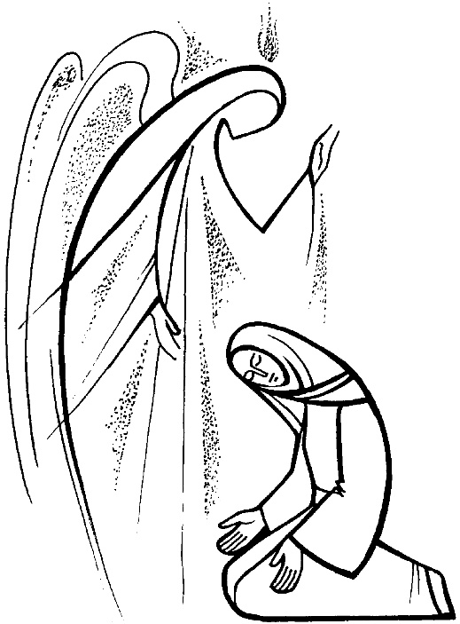

The Congregational Church
of
North Stonington, U.C.C.

89 Main Street
North Stonington, CT 06359
860-535-0379
NoStoUCC@comcast.net
www.NoStoUCC.org

December 14, 2025

THIRD Sunday of Advent 10 a.m.

“As an Open and Affirming church:
We respect the worth and dignity of all persons who come into our church family regardless of race, age, marital standing, gender, economic status, mental or physical challenges, nationality or sexual orientation. We promise to support one another in our personal struggles, to understand and accept differences in one another, and pray to strengthen our love and acceptance.”

*indicates those who are able are invited to stand

WELCOME AND SHARING THE WORK OF THE CHURCH

PRELUDE Voluntary and Fughetta on
“Come, Thou Long-Expected Jesus” Callahan

SILENT MEDITATION IN PREPARATION FOR WORSHIP
CALL TO WORSHIP
Jeremiah said, “I am only a boy.”
Moses said, “Who am I to do this work?”
Mary said, “How can this be?”
We often say, “But God, I am afraid.”
Even when we are afraid, God invites us closer.
So may we trust the Inviter.
May we heed God’s invitation.
May we summon our courage and sing God’s praise.
Let us worship our courageous, inviting, calling God. Amen!

HYMN #107 Awake and Greet the New Morn Rejoice, Rejoice

PRAYER OF INVOCATION AND LORD’S PRAYER (debts, debtors)
The story of this season is not a new one, and yet we long to hear it again. Spark our spirits awake. Call forth awareness, attention, and reverence in us. Allow us to hear this ancient tale with brand new ears. With hope we pray, Our Father…

*GLORIA PATRI (#759)
Glory to the Creator, the Christ, the Holy Spirit
Three in One; As it was in the beginning,
Is now and ever shall be, world without end. Amen, amen.

ADVENT WREATH LIGHTING The Gadaree Family
Let us pray: Now we have come again, dear Lord, to the time of the Morning Star, to yourself moving as azure blue into our contamination; as open touch to our fisted exclusiveness; as a carol sung to our meagerness; as Rose to our bitterness; as love to our emptiness. You are upon us as sky, hands, songs, garlands, tastes … making us yours in joy. We marvel not that angelic hosts sang and shouted for joy. Amen.
Sung response to tune of O Come Emmanuel:
“O Come, O come Emmanuel.”
Come, lift the weight of wea - riness.
Come bring your joy to all of our days.
And set us free to sing … your praise,
How long? Not long. Emmanuel
is come to us, to all the world.

*PASSING OF THE PEACE (we offer a sign of Christ’s peace)
May the peace of Christ be with you.
And also with you.

TIME FOR CHILDREN

SCRIPTURE LESSONS (OT page 663) Isaiah 35
(NT page 57) Luke 1:46b-55

ANTHEM “Rejoice, Rejoice, Believers” arr. K. Lee Scott

SERMON Singing Hard Times Away

MOMENTS OF SILENCE

*HYMN #106 My Heart Sings Out Marias Lovsång

OFFERING OF OUR TITHES AND GIFTS
You may also at this time place Prayer Requests in offering plates.

OFFERTORY “Shepherd’s Pastorale” Wilson

*DOXOLOGY (#780)
Praise God from Whom all blessings flow;
Praise God all creatures here below;
Praise God above, you heavenly host;
Creator, Christ, and Holy Ghost. Amen.

*PRAYER OF DEDICATION

PRAYER OF INTERCESSION response: Lord, hear our prayer

*HYMN #122 Come, O Long-Expected Jesus Stuttgart
*BENEDICTION
POSTLUDE “Rejoice, Rejoice, Believers! arr. L. Smith
Please exit quietly so those who wish to stay and listen may.

We are live-streaming on You tube and Facebook.

Welcome. Thank you for worshiping with us today! All children are welcome to attend church school. A nursery is located downstairs.
The service is available at nostoucc.org

We light one white candle each Sunday to remember and pray for military and civilians serving our country and in harm’s way.

The flowers are given to the Glory of God in memory of Joanne Sherman by Pastor Sue.

Serving in Worship: Kathi Thaxton, deacon; Paul Ames, Julie Clow, ushers; Monica Eppinger, lay reader.

We Pray For: Stephanie and Doug Murray; George McCullen; Aggie Terrill; Kevin Ames; Rev. Lee Ireland; Amy Foster; Marilyn Barr; Jason Lautzenheiser; Debbie Janda; Kim Allard; Lillian Hesselman, Kim’s friend who recently passed away; David Allard who is on life support; Paul Ames; Mike Baker; Julie Evans; Pam Cekala; Sue Pianka; Mary Stilli (Elizabeth Witter’s daughter); Raul Rois; Ray Wells; Brian Hager; Gabby Ricci; and Patty Danley and Dave McCord.
Prayer requests remain for 6 weeks unless otherwise requested.

CALENDAR
Today - After Worship (for 20 minutes) - Cherub Choir with Mrs. Thaxton in Choir room. (ages 3 and up. Children will sing on Dec. 21 at 10 am worship (and at Live Nativity on Thursday)
Today 3 pm: Stonington Madrigal Singers here in our sanctuary. FREE admission. Donations gratefully accepted. Reception following concert.
Monday, 10:30: Study Group, “The Case for Christmas”
Tuesday, 9-11 am in Hewitt Hall: Free breakfast sponsored by The Wheeler Middle School eight grade class.
Thursday: 5:00 pm: Youth Choir
5:30 pm: Preparations for participants in Live Nativity
6:00 pm: Live Nativity outside in front lawn
After Live Nativity - Sr. Choir
7:15-8:30 PM: Handbell Choir

COMING EVENTS
December, 24 - Christmas Eve
5:00 pm: Family Service with Youth Choir and Alice Robbins,
soloist
9:30 pm: Prelude Music with Sr. Choir, Handbell Choir and
Michelle Macina, flutist
10:00 pm: Candlelight Service with choirs and soloist, Renee
Celey

Please show appreciation for retired clergy and their families…
“Grace upon Grace.” John 1:16
We collect your special offerings for the Christmas Fund throughout December. Caring for our pastors in the UCC.
United Church of Christ congregations and members have blessed the Christmas Fund of the Pension Board with their generosity for many years. This year, your care and compassion will be especially appreciated by those servants of the church who are facing a time of need. Thank you!

Habitat for Humanity is looking for Homeowner Engagement Volunteers and Homeowner Support Volunteer (see bulletin board for more information or visit HFHECT.org)

SENIOR CHOIR ANTHEM - Arr.: K. Lee Scott
Rejoice, rejoice, believers,
And let your lights appear;
The evening is advancing,
And darker night is near.
The bridegroom is arising
And soon is drawing nigh.
Up, pray and watch and wrestle;
At midnight comes the cry.

The watchers on the mountain
Proclaim the bridegroom near;
Go forth as he approaches
With alleluias clear.
The marriage feast is waiting;
The gates wide open stand.
Arise, O heirs of glory;
The bridegroom is as at hand.

The saints, who here in patience
Their cross and suff’rings bore;
Shall live and reign forever
When sorrow is no more.
Around the throne of glory
The Lamb they shall behold;
In triumph cast before him
Their diadems of gold.

Our hope and expectations,
O Jesus, now appear;
Arise, O Sun so longed for,
O’er this benighted sphere.
With hearts and hands uplifted,
We plead, O Lord, to see
The day of earth’s redemption
That sets your people free!

All Hymns from the (NCH) New Century Hymnal; © 1995 The Pilgrim Press, have been granted permission for this one-time use. Permission to reprint, podcast, and / or stream the music in this service obtained from ONE LICENSE with license #735340-A. All rights reserved.
Call to worship & Invocation adapted, by Rev. Sarah (Are) Speed, A Sanctifed Art LLC; sanctifedart.org


POINSETTIAS
FOR
CHRISTMAS

At the Congregational Church
of North Stonington
United Church of Christ

I would like to have a plant in church

given by

⃞ in memory of

⃞ in honor of

⃞ I will bring the plant on/or before Thursday,
December 18th.

⃞ I am donating money for a poinsettia by December 18th.
($15 minimum, enclosed).

To allow the flower committee ample time to arrange plants, they must be delivered to the church by NOON on Wednesday, December 18th and all plants should be clearly marked with donor(s) names.

Thank you!

14 December 2025 Advent 3

“What do I want for Christmas?” Ann Weems
What do I want for Christmas?
I want to kneel in Bethlehem,
the air thick with alleluias,
the angels singing
that God is born among us.
In the light of the Star,
I want to see them come,
the wise ones and the humble.
I want to see them come
bearing whatever they treasure
to lay at the feet of him who gives his life.
What do I want for Christmas?
To see in that stable
the whole world kneeling in thanks
for a promise kept:
New life.
For in his nativity
We find ours.

Global Ministries Prayers for Prayers for Taiwan - Dear God, we give thanks for the congregations and institutions of our partner in Taiwan, the Presbyterian Church in Taiwan, and for the communities where people gather to care for one another in times of joy and in seasons of hardship. We thank you for the courage shown amid typhoons, earthquakes, and uncertainty, and for all who labor to bring comfort, repair, and hope.

May your Spirit deepen our partnership, that together we may embody compassion, justice, and resilience.
We pray this in Jesus’ name. Amen.

Our Ministers: the congregation Susan G. Latourette, Pastor – 860-759-4231, pastorsuel@yahoo.com Michael G. Noonan, Director of Music
Margaret Leonard, Christian Education Coordinator Rosemary Kuemper, Church Secretary Charlotte Melia, Sexton
Office hours: Monday –Thursday, 9am - 1 pm 860-535-0379

