Global Ministries Mission Prayers for the Democratic Republic of Congo:
“Almighty God, we turn our gaze to You in these times of distress in the Democratic Republic of Congo. We pray especially for the people of the Eastern provinces of North Kivu, South Kivu, and Ituri, without forgetting the provinces of Kwilu, Kwango, and Maindombe in the West.

We pray for the thousands of refugees and the millions of people living in inhumane conditions, women who have been raped, and children who have been abandoned. We pray for the elderly who have no help in their isolation.

We pray for their comfort and also for all those suffering from illness, injury, trauma, violence, and rejection.
May Your mighty hand bring healing through the stripes of Jesus Christ to wounded bodies and broken souls.

Almighty Lord, we implore Your peace that surpasses all understanding and reconciliation with true mutual forgiveness so that war may end.

Lord, listen.
Lord hear us and Lord act.
In the Name of Jesus Christ.
Amen!

Susan G. Latourette, Pastor – 860-759-4231, pastorsuel@yahoo.com
Michael G. Noonan, Director of Music
Margaret Leonard, Christian Education Coordinator
Rosemary Kuemper, Church Secretary
Charlotte Melia, Sexton Office hours: Monday -Thursday, 9am – 1PM

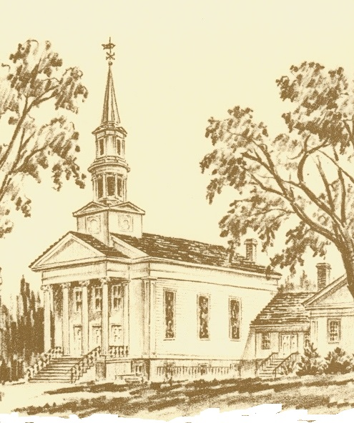

The Congregational Church
of
North Stonington, U.C.C.

89 Main Street
North Stonington, CT 06359
860-535-0379
NoStoUCC@comcast.net
Website: nostoucc.org

October 19, 2025
20th Sunday after Pentecost 10 am
Ás an Open and Affirming church:
We respect the worth and dignity of all persons who come into our church family regardless of race, age, marital standing, gender identity, economic status, mental or physical challenges, nationality or sexual orientation. We promise to support one another in our personal struggles, to understand and accept differences in one another, and pray to strengthen our love and acceptance.”

*indicates those who are able are invited to stand

WELCOME AND THE WORK OF THE CHURCH

Handbell Prelude “Grand March” - McChesney
SILENT MEDITATION IN PREPARATION FOR WORSHIP

*CALL TO WORSHIP
As we gather in the welcome of God’s love, in the unity of Christ, in the power of the Spirit, let us listen for the voice of God.
Let us worship God, who has spoken and still speaks to those who listen.
God is the source of our life’s journey, the guide, and the destination.
May this time of worship help us grow in faith as we journey together.

*HYMN #8 Praise to the Living God DIADEMATA

*INVOCATION AND LORD’S PRAYER (debts/debtors)
We turn to you, O God, as we seek through prayer to find meaning and direction in our lives. All too often it is a fleeting prayer as we juggle the many concerns of our lives. We pray for patience when there are too many things to be done. We pray for wisdom when faced with tough questions. We pray for courage when we see injustice in our world. We pray for faith to know you are listening, as we pray together: Our Father . . .
*GLORIA PATRI (#759)
Glory to the Creator, the Christ, the Holy Spirit
Three in One; As it was in the beginning,
Is now and ever shall be, world without end. Amen.

*PASSING OF THE PEACE
May the peace of Christ be with you.
And also with you.
(We greet one another with a sign of Christ’s peace)

TIME FOR CHILDREN
Children are invited to attend church school.

SCRIPTURE (NT page 213) 2 Timothy 3:14-4:5
(NT page 81) Luke 18:1-8

CHOIR ANTHEM “In This Room” - Albrecht and Althouse

SERMON Faith and persistence

MOMENTS OF SILENCE

HYMN #510 Grant Us Wisdom to Perceive You QUEM PASTORES

OFFERING OF OUR TITHES AND GIFTS
(The ushers will collect the offering and Prayer requests.)
Handbell Offertory “What a Friend We Have in Jesus”
-Sharon Elery Rogers
*DOXOLOGY (#780)
Praise God from Whom all blessings flow;
Praise God all creatures here below;
Praise God above, you heavenly host;
Praise Father, Son and Holy Ghost. Amen.

*PRAYER OF DEDICATION
PRAYERS OF THE PEOPLE Response: Lord hear our prayer…

HYMN #21 God Reigns o’er All the Earth TERRA BEATA
*BENEDICTION

POSTLUDE “Exultation” - Callahan

We are live-streaming our services for home viewing
on YouTube and Facebook

Thank You for Worshiping with us! Welcome Guests! You are invited to sign our guest book in the entry or complete the welcome card in your pew. Please join us for fellowship, Fair Trade Coffee and snacks in Hewitt Hall after worship. Church school is open to all.

We light one white candle each Sunday to remember and pray for military and civilians serving our country and in harm’s way.

Today we welcome the Rev. Dr. Mobby Larson as guest preacher today. Mobby is a “mostly retired” UCC pastor, and is the retired pastor of Ledyard Congregational Church (UCC). She serves as a supply preacher in local churches and is a musician as well, ringing in our handbell choir as well as EmBellish Handbell Ensemble, sings in our Sr. Choir, and is a pianist, who has helped lead our worship many times. We are blessed to have Mobby sharing her ministry with us this morning.

The flowers are given to the glory God by Dennis and Mary Bliven in celebration of Elaine and Brad Ricci’s anniversary.

Serving in Worship Dave McCord, deacon; Gretchen Noonan, Kevin Noonan, ushers; Sherri Boldt, lay reader.

We Pray For: Stephanie and Doug Murray; George McCullen; Aggie Terrill; Kevin Ames; Rev. Lee Ireland; Amy Foster; Marilyn Barr; Jason Lautzenheiser; Debbie Janda; Kim Allard; Paul Ames; Mike Baker; Julie Evans; Pam Cekala; Sue Pianka; Sharon Roode; Patty Danley; Mary Stilli (Elizabeth Witter’s daughter); Raul Rois; Ray Wells; and Marty Booker.
Prayer requests remain for 6 weeks unless otherwise requested.

CALENDAR
Today after worship: Youth Choir
Today, 11:15 am: Budget Meeting
1 pm: CWS Crop Walk, Mystic
Monday, 10:30 am: Study Group
Thursday: Making Pies a.m. only
6:00-7:00 PM: Sr. Choir
7:15-8:30 PM : Handbell Choir
Jammie Grammie
October 1 – November 22, Jammie Grammie is collecting pajamas with First Baptist Church. Please bring in sets of new pajamas, any size: Babies and Toddlers to size 16.. Box available in Hewitt Hall. Thank you from the Jammie Grammie!

ANTHEM - Albrecht
In this room there is a feeling of peace.
In this room in, in this very room.
A peace that will lift you up,
peace that will fill your heart.
In this room, in this very room.

In this room there is a feeling of love.
In this room, in this very room.
A love that will lift you up,
a love that will fill your heart.
In this room, in this very room.

For God said build me a church, a place that welcomes all;
mighty and the lowly, the great and the small.
The beggar and the wise man, the fancy and the plain,
those who thirst or hunger, those who are in pain.
We’re all the same.

In this room there is a feeling of joy.
In this room, in this very room.
Now go forth and spread the peace,
the love and the joy
from this very room!

Worship Notes: All Hymns from the (NCH) New Century Hymnal; © 1995 The Pilgrim Press, have permission for one-time use. Permission to reprint, podcast, and / or stream the music in this service obtained from ONE LICENSE with license #735340-A. Call to Worship, adapted from Barbara Smith Blessing New Voices. Invocation, call to prayer, Iona Abbey Worship Book, p 24.

