“When the day of Pentecost came, they were all together in one place. Suddenly a sound like the blowing of a violent wind came from heaven and filled the whole house where they were sitting.’” - Acts 2:1-2 (NRSV)
On the great day of Pentecost, a mighty wind surged forth from heaven, pushing the followers of Jesus out of the house where they had been hiding, and into the streets. Flames danced above their head, their tongues began to wag, and people from all over the world heard what they said – no matter what their native language.
Peter gave a sermon which would cause Billy Graham or Joel Osteen to turn green with envy – and three thousand people were baptized.
The Church of Jesus Christ was born!

On the day after Pentecost:
Peter’s wife had to yell at him three times to get out of bed, so that he would get his sermon on the website before 9 a.m.
The deacons grumbled about cleaning out the baptismal pool.
And the apostles argued about who got to preach on Trinity Sunday, who would choose the hymns, and who would be stuck chairing the Nominating Committee.
Come, Holy Spirit, with your gracious language.
Come, Holy Spirit, with your passion for all people.
Come, Holy Spirit with your uniting peace.
Come, Holy Spirit! -Thom M. Shuman

Global Ministries Prayers for Chile - Let us pray that, as the Pentecostal Church of Chile, we may continue to be rivers of living water that quench the spiritual thirst of those who need it. May we faithfully reflect God’s love, bringing hope to every corner. Let us also pray for the Shalom Center, that it may continue to be a source of life, care for creation, and holistic restoration. And especially, let us pray for each person who comes to this place, that they may be profoundly transformed, healed, and restored by God’s love, and that this river of life may continue to flow in them and through them. Amen

Our Ministers: the congregation Susan G. Latourette, Pastor – 860-759-4231, pastorsuel@yahoo.com Michael G. Noonan, Director of Music
Margaret Leonard, Christian Education Coordinator Rosemary Kuemper, Church Secretary Charlotte Melia, Sexton
Office hours: Monday –Thursday, 9am - 1 pm 860-535-0379

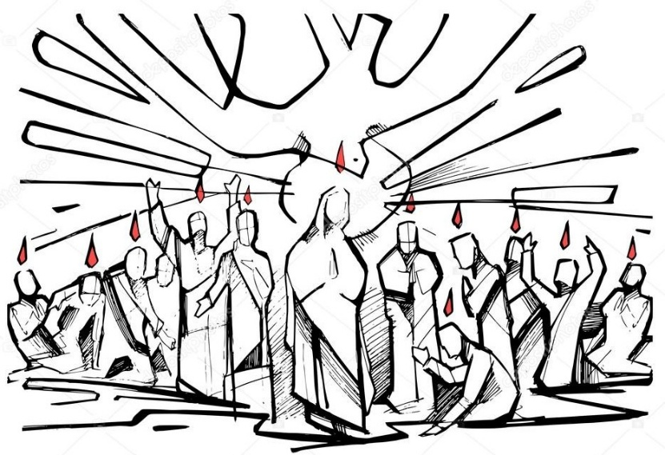

The Congregational Church
of
North Stonington, U.C.C.

89 Main Street
North Stonington, CT 06359
NoStoUCC@comcast.net
NoStoUCC.org

May 24, 2026
Memorial Sunday, Pentecost

PENTECOST 10 a.m. “As an Open and Affirming church:
We respect the worth and dignity of all persons who come into our church family regardless of race, age, marital standing, gender identity, economic status, mental or physical challenges, nationality or sexual orientation. We promise to support one another in our personal struggles, to understand and accept differences in one another, and pray to strengthen our love and acceptance.”

*indicates those who are able are invited to stand

WELCOME AND SHARING THE WORK OF THE CHURCH

Prelude “Come, Father, Son, and Holy Spirit” - Thomas Bliss

SILENT MEDITATION IN PREPARATION FOR WORSHIP

*CALL TO WORSHIP
God speaks to us…
In the riches of Creation.
God speaks to us…
Through the stories of Jesus.
God touches us…
With the lives of other people.
God speaks to us…
In words and ways we cannot understand.
*HYMN #286 Spirit Spirit

*PRAYER OF INVOCATION AND LORD’S PRAYER (debts, debtors)
O God of Holy Fire, continue to burn brightly in your Church. This is also a day on which we recognize the gift of memory. Our hearts and minds are full of gratitude for those who came before us in this place. We lift those who gave themselves – often their lives – serving our country. Now help us remember You are our God and we your people. Kindle in our hearts the fire of your love as we pray: .…Our Father…

*GLORIA PATRI (#759)
Glory to the Creator, the Christ, the Holy Spirit
Three in One; As it was in the beginning,
Is now and ever shall be, world without end. Amen, amen.
*PASSING OF THE PEACE (we offer a sign of Christ’s peace)
May the peace of Christ be with you.
And also with you.

TIME FOR CHILDREN - MEMORIAL BLESSING
Eternal God, we remember before you this day all who rest from their labors, especially those who gave their lives in service to this country. On this 305th Anniversary of this church, we remember with gratitude the faithful who have maintained this body of Christ in the community.
It is in their memory that we offer this prayer.
We also ask your blessing upon these memorial plants in honor Ebenezer Russell, Joseph Fish, Nathan Avery, Stephen Hubbell, Frederic M. Hollister, Inor Partington, and Newell E. Bishop, who ministered from 1974 to 1999.
May we honor our covenant with you, O God, as we give thanks for all who faithfully served this congregation. May our giving and our remembering be blessed in your sight, our Rock and our Redeemer. Amen.

SCRIPTURE LESSONS (NT page 99) John 7:2-5, 37-39
(NT page 119) Acts 2:1-21

CHOIR ANTHEM “Come Down, O Love Divine” - arr. Dietterich

SERMON “Earth, Wind and Fire”

MOMENTS OF SILENCE

*HYMN #58 Spirit of Love Perfect Love

OFFERING OF OUR TITHES AND GIFTS
You may also at this time place Prayer Requests in offering plates.

Offertory “Spirit of the Living God” - Emma Lou Diemer

*DOXOLOGY (#780)
Praise God from Whom all blessings flow;
Praise God all creatures here below;
Praise God above, you heavenly host;
Creator, Christ, and Holy Ghost. Amen.

*PRAYER OF DEDICATION

PRAYERS OF INTERCESSION Response: Lord, hear our prayer

*HYMN #564 We Are Not Our Own Yarnton
*BENEDICTION

Postlude “Come, Holy Ghost, God and Lord” - Jeffrey Blersch
Please exit quietly so those who wish to stay and listen may

We live-stream on Youtube and Facebook thru nostoucc.org

Welcome! Thank you for worshiping with us today! All children are welcome to attend church school. Please join us for conversation and Fair-Trade Coffee after worship in Hewitt Hall. Please sign our guest book at the entryway or fill out a pew card so we can get to know you.

We light one white candle each Sunday to remember and pray for military and civilians serving our country and in harm’s way. The sunflowers are a symbol of prayer for Ukraine.

Memorial Plants are given in honor of:
Ebenezer Russell, first settled minister of this church, 1727 to 1731;
Joseph Fish, 1732 to 1781;
Nathan Avery, Strict Congregational Church, 1759 to 1780;
Stephen Hubbell, 1853 to 1869;
Frederic M. Hollister, 1909-1914;
Inor Partington, 1925 to 1937;
Newell E. Bishop, 1974 to 1999.

The steeple is lit this week by Julie Evans in honor of all veterans on this Memorial Day.

Serving in Worship Kathi Thaxton, deacon at the door; Matthew Sander, Steve Gadaree, ushers; Sherri Boldt, lay reader.

We Pray For: Stephanie and Doug Murray; George McCullen; Aggie Terrill; Kevin Ames; Rev. Lee Ireland; Amy Foster; Debbie Janda; Kim Allard; David Allard; Mike Baker; Sue Pianka; Mary Stilli (Elizabeth Witter’s daughter); Ray Wells; Patty Danley; Dave McCord; Robert Fox; Elizabeth Bouchard; Julie Evans; Kathi Thaxton; Marilyn Ware; Clare Whitney; Betsy Alvarez; Elizabeth Witter; Paul Ames, and Michael Noonan.
Prayer requests remain for 6 weeks unless otherwise requested.

Monday: Office closed in observance of Memorial Day.
Thursday: Pie-assembly a.m. & p.m.
5:00 - 5:40 pm: Youth Choir

Sunday: HELO Guest Speaker, Elisabeth Kennedy
Coming Events
May 31, 6 pm: AGO Annual Meeting
June 6, 11 am: Lautzenheiser Memorial Service
8, 7 pm: Church Council
13th, 11 am: Mishovich Memorial Service

CHOIR ANTHEM arr. Dietterich
Come down, O love divine, Seek thou this soul of mine,
And visit it with thine own ardor glowing;
O Comforter, draw near, Within my heart appear,
And kindle it, thy holy flame bestowing.

O let it freely burn, Till earthly passions turn
to dust and ashes in its heart consuming;
And let thy glorious light shine ever on my sight,
And clothe me round, the while my path illuming.

And so the yearning strong With which the soul will long
Shall far outpass the power of human telling;
For none can guess its grace, Till he become the place
Wherein the Holy Spirit makes his dwelling. Amen.

All Hymns from the (NCH) New Century Hymnal; © 1995 The Pilgrim Press, have been granted permission for this one-time use. Permission to reprint,
podcast, and / or stream the music in this service obtained from ONE LICENSE with license #735340-A. All rights reserved. Call to worship by Ruth Burgess in Fire & Bread, p 148

