“For God did not send the Son into the world to condemn the world, but to save the world through him.” - John 3:17
There is an old legend that after his death, Judas found himself at the bottom of deep and slimy pit. For thousands of years he wept his repentance. He tried to reach the pinpoint of light above but kept falling. After thousands more years, he dragged himself into an upper room with twelve people around a table. Jesus said, “We’ve been waiting for you. We couldn’t start without you.”
This story offends some clergy. “But God, the Good Book tells us, is no respecter of persons, and the happy ending isn’t promised to an exclusive club. . . What God began, God will not abandon. He who began a good work in you will carry it on to completion. God loves everyone, sings the psalmist. What God has named will live forever!”
“The happy ending has never been easy t believe in. . . Even when the women told the disciples that Jesus had left the stone-sealed tomb, the disciples found it nearly impossible to believe that t it was not all over. The truth was, it was just beginning.”
-Madeleine L’Engle, “Waiting for Judas” in The Rock that is Higher

Global Ministries Prayers for Lesotho: Gracious and risen Lord
We come before you today with the same longing for your peace as your disciples. Lord, we lift up Lesotho into your loving hands. Let your peace dwell in our land, in our leaders, and in every village and home. Heal divisions, guide those in authority with wisdom, and help our nation walk in justice, compassion, and truth. As you sent your disciples into the world, send us also to be witnesses of your resurrection and your hope. Bless the communities and people we serve. Where there is suffering, bring healing; where there is doubt, plant faith; where there is despair, awaken hope. Lord, like Thomas, help us to believe more deeply and confess with our lives: “My Lord and my God.” Amen.

Our Ministers: the congregation Susan G. Latourette, Pastor – 860-759-4231, pastorsuel@yahoo.com Michael G. Noonan, Director of Music
Margaret Leonard, Christian Education Coordinator Rosemary Kuemper, Church Secretary Charlotte Melia, Sexton
Office hours: Monday –Thursday, 9am - 1 pm 860-535-0379

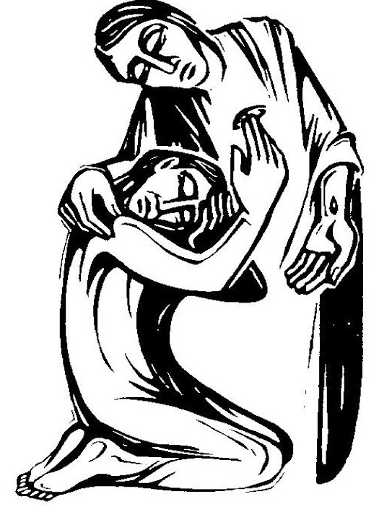

The Congregational Church
of
North Stonington, U.C.C.

89 Main Street
North Stonington, CT 06359
860-535-0379
NoStoUCC@comcast.net
NoStoUCC.org

April 12, 2026
SECOND SUNDAY OF EASTER 10 a.m.
“As an Open and Affirming church:
We respect the worth and dignity of all persons who come into our church family regardless of race, age, marital standing, gender identity, economic status, mental or physical challenges, nationality or sexual orientation. We promise to support one another in our personal struggles, to understand and accept differences in one another, and pray to strengthen our love and acceptance.”

*indicates those who are able are invited to stand

WELCOME AND SHARING THE WORK OF THE CHURCH

Prelude “Fanfare on With High Delight Let Us Unite” - Callahan

SILENT MEDITATION IN PREPARATION FOR WORSHIP

*CALL TO WORSHIP Psalm 118:24, adapted
God calls us this day to a life of joy.
With God, joy breaks through the bonds of despair.
With God, joy bursts forth from moments of quiet pleasure.
With God, joy gilds the edges of even ordinary days.
This is the day which our God has made;
let us rejoice and be glad in it.

*HYMN #242 The Strife is O’er Victory

*PRAYER OF INVOCATION AND LORD’S PRAYER (debts, debtors)
We come before you, O God, in Easter joy, seeking to be a people of the resurrection. Be known among us; grant us the assurance of your presence, you love, and your renewing power. Through your Word and Spirit, reveal to us your purpose in our lives. We pray in the name of the risen Christ, Our Father . . .

*GLORIA PATRI (#759)
Glory to the Creator, the Christ, the Holy Spirit
Three in One; As it was in the beginning,
Is now and ever shall be, world without end. Amen, amen.

*PASSING OF THE PEACE (we offer a sign of Christ’s peace)
May the peace of Christ be with you.
And also with you.

TIME FOR CHILDREN

SCRIPTURE LESSONS (NT page 232) 1 Peter 1:3-9
(NT page 115) John 20:19-23

CHOIR ANTHEM “We Walk by Faith” - Kosche

SERMON “Moving into Joy”

MOMENTS OF SILENCE

*HYMN #255 Jesus, Sovereign, Savior King’s Weston

OFFERING OF OUR TITHES AND GIFTS
You may also at this time place Prayer Requests in offering plates.

Offertory “Voluntary on This Joyful Eastertide” - Callahan

*DOXOLOGY (#780)-
Praise God from Whom all blessings flow;
Praise God all creatures here below;
Praise God above, you heavenly host;
Creator, Christ, and Holy Ghost. Amen.

*PRAYER OF DEDICATION

PRAYER OF INTERCESSION response: Lord, hear our prayer

*HYMN #256 We Live by Faith and Not by Sight Dunlap’s Creek

*BENEDICTION

Postlude “Good Christian Friends, Rejoice and Sing!” -Burkhardt

Please exit quietly so those who wish to stay and listen may

We are live-streaming on Youtube and Facebook.
Welcome. Thank you for worshiping with us today! All children are welcome to attend church school. Please join us for conversation and Fair-Trade Coffee after worship. The service is available at nostoucc.org

We light one white candle each Sunday to remember and pray for military and civilians serving our country and in harm’s way. The sunflowers are a symbol of prayer for Ukraine.

The flowers are given to the Glory of God.

Serving in Worship Kevin Noonan, deacon at the door; Patty Danley, Monice Eppinger, ushers; Alice Robbins, lay reader.

We Pray For: Stephanie and Doug Murray; George McCullen; Aggie Terrill; Kevin Ames; Rev. Lee Ireland; Amy Foster; Debbie Janda; Kim Allard; David Allard; Paul Ames; Mike Baker; Pam Cekala; Sue Pianka; Mary Stilli (Elizabeth Witter’s daughter); Raul Rois; Ray Wells; Patty Danley; Dave McCord; Robert Fox; Elizabeth Bouchard; Julie Evans; Kathi Thaxton; Marilyn Ware; and Claire Whitney.
Prayer requests remain for 6 weeks unless otherwise requested.

Monday, 10:30 am: Study Group
7 pm: Church Council
Tuesday, 5 – 6:30 pm: Spaghetti & Meatball Community Dinner
Wednesday, Noon: Women’s Connection, (formerly Women’s
Fellowship) brown bag lunch
Thursday: NO Youth Choir
6:00-7:00 PM - Sr. Choir
7:15-8:30 PM - Handbell Choir
Saturday, 10-12: Old Plains Cemetery clean -up day

COMING EVENTS
April 26, after worship: Youth Choir

Mission Focus for April HELO Haiti
HELO ORPHANAGE AND SCHOOL are in les Cayes which is much calmer than much of Haiti, and for that we are grateful. Still, we must pray and support their challenges and needs:
· Food and other necessities like soap and toothpaste.
· Roads remain blocked, airspace closed, ports are under gang control, all of which makes for a severely limited stream of commerce.
· Prices that continue to skyrocket. We are grateful that we have been able to continue to provide three meals a day to our children and staff, but we cannot continue to do so without help.
· Maintaining a safe and loving environment of our children.
· Health needs for the children and their families
· Building improvements
· Weather issues that occur frequently.
Please help us pray for Haiti, for families' safety and relief from fear and hunger. Please pray that we at HELO can continue to support an ever increasing budget resulting from inflated prices and food scarcity. Please use the green mission envelopes.

“We Walk by Faith” by Kosche

We walk by faith and not by sight;
No gracious words we hear
From Christ, who spoke as none e’er spoke;
But we believe Him near.

We may not touch His hands and side
Nor follow where He trod;
But in His promise, we rejoice,
And cry, “My Lord and God!“

Help then, O Lord, our unbelief;
And may our faith abound
To call on You where You are found:

That, when our life of faith is done,
In realms of clearer light
We may be hold You
With full and endless sight.

All Hymns from the (NCH) New Century Hymnal; © 1995 The Pilgrim Press, have been granted permission for this one-time use. Permission to reprint, podcast, and / or stream the music in this service obtained from ONE LICENSE with license #735340-A. All rights reserved.

