“You are the light of the world.” - Matthew 5:14 Summer sunlight changes everything it touches. Plants grow, waters warm, animal patterns change. The sun’s light has the power to change our moods. It is our best and easiest resource for
Vitamin D.
We, too, have been given the capacity to bring warmth, kindness, encouragement, and hope into the lives around us, changing everything we encounter. And not only have we been gifted with the light, but we have been called to share it.
Small acts of love shine brighter than we realize. Light will always dispel the darkness. -Carrin Mahmood

Global Ministries Prayers for Laos - Gracious and loving God, we come before you with grateful hearts, lifting the country of Laos and its people into your loving care. We pray for the nation and its government as Laos continues to build its future and seeks to address the needs of all its people. We especially bring before you the Christian community in Laos, and the Lao Evangelical Church with its many ministries that bless and uplift the people of the nation. At this time, we remember the students from the Lao Evangelical Church who are currently engaged in theological training. We pray that they may complete their studies with joy and dedication, and that they may become faithful servants in your vineyard in Laos. As we are assured in the scripture reading for this day, we ask that you grant rest to all the people of Laos and to all of us who carry heavy burdens. Help us to experience the truth that your yoke is easy and your burden is light. In the precious name of our Lord and Savior Jesus Christ, we pray, Amen.

Our Ministers: the congregation Susan G. Latourette, Pastor – 860-759-4231, pastorsuel@yahoo.com Michael G. Noonan, Director of Music
Margaret Leonard, Christian Education Coordinator Rosemary Kuemper, Church Secretary Charlotte Melia, Sexton
Office hours: Monday –Thursday, 9am - 1 pm 860-535-0379

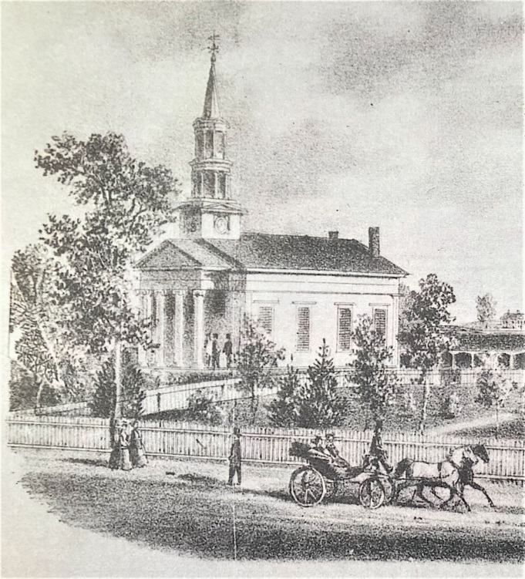

The Congregational Church
of
North Stonington, U.C.C.

89 Main Street
North Stonington, CT 06359
NoStoUCC@comcast.net
NoStoUCC.org

June 28, 2026
FIFTH SUNDAY OF PENTECOST 10 a.m.
“As an Open and Affirming church:
We respect the worth and dignity of all persons who come into our church family regardless of race, age, marital standing, gender identity, economic status, mental or physical challenges, nationality or sexual orientation. We promise to support one another in our personal struggles, to understand and accept differences in one another, and pray to strengthen our love and acceptance.”

*indicates those who are able are invited to stand

WELCOME AND SHARING THE WORK OF THE CHURCH

Prelude “Amazing Grace” - Hal Hopson

SILENT MEDITATION IN PREPARATION FOR WORSHIP

CALL TO WORSHIP Psalm 16 v 1-3
Preserve us, O God, for in you we take refuge.
“You are our God; we have no good apart from You.
You give us counsel, all the day and through the night.
We set you always before us, because you are at our
right hand, we shall not be moved.

*HYMN #12 I Sing the Mighty Power of God Ellacombe

Prayer of Invocation
Life-giving God, there is much doubt and despair in our world. We often feel weighed down by it. Help us to always make the choice for Life. Help us affirm what can be affirmed; and to hope where hope is possible; and to risk ourselves to lift up human dignity. We pray in the name of Christ, the Way, the Truth and the Life: Our Father….

*GLORIA PATRI (#759)
Glory to the Creator, the Christ, the Holy Spirit
Three in One; As it was in the beginning,
Is now and ever shall be, world without end. Amen, amen.

*PASSING OF THE PEACE (we offer a sign of Christ’s peace)
May the peace of Christ be with you.
And also with you.

Time for children

SCRIPTURE LESSONS (OT page 446) Esther 4:1-17
(NT page 69) Luke 9:23-25

SERMON “In Jeopardy”

MOMENTS OF SILENCE

*HYMN #35 O Mighty God, When I Survey in Wonder O Store God

OFFERING OF OUR TITHES AND GIFTS
You may also place Prayer Requests in offering plates.

Offertory “Morning Prayer” - Tchaikovsky (1840-1893)

*DOXOLOGY (#780)
Praise God from Whom all blessings flow;
Praise God all creatures here below;
Praise God above, you heavenly host;
Creator, Christ, and Holy Ghost. Amen.

*PRAYER OF DEDICATION

PRAYERS OF INTERCESSION Response: Lord, hear our prayer

*HYMN #583 Like a Mother Who Has Borne Us Austin
*BENEDICTION

Postlude “A Festal Fanfare” - J. S. Bach (1685-1750)

Please exit quietly so those who wish to stay and listen may

We live-stream on Youtube and Facebook: see nostoucc.org

Welcome! Thank you for worshiping with us today! All children are welcome to attend church school. Please join us for conversation and Fair-Trade Coffee after worship in Hewitt Hall. Please sign our guest book at the entryway or fill out a pew card so we can get to know you.

We light one white candle each Sunday to remember and pray for military and civilians serving our country and in harm’s way. The sunflowers are a symbol of prayer for Ukraine.

The flowers are given to the Glory of God.

Serving in Worship Anne Nelson, deacon; Monica Eppinger, Patty Danley, ushers; Dave McCord, lay reader.

We Pray For: Stephanie and Doug Murray; George McCullen; Aggie Terrill; Kevin Ames; Rev. Lee Ireland; Amy Foster; Debbie Janda; Mike Baker; Sue Pianka; Mary Stilli (Elizabeth Witter’s daughter); Ray Wells; Patty Danley; Robert Fox; Elizabeth Bouchard; Julie Evans; Marilyn Ware; Clare Whitney; Betsy Alvarez; Elizabeth Witter; Paul Ames; and Dave McCord;
Prayer requests remain for 6 weeks unless otherwise requested.

Rosemary will be on vacation starting July 6 and returning to the
office on July 20.

Graduations Happen! if you or a loved one has graduated or will be graduating from high school or college, or receiving a certificate or an advanced degree, we’d like to recognize you in the July/August Chimes. Just let us know who is graduating, the school, date of the
graduation and degree. Please don’t assume we already know. We don’t want to leave you out!

Summer Music Our choirs have earned a well-deserved break for the summer. During summer worship, we offer our “Summer Music” program. Anyone is invited to offer a song during summer worship. You do not need to be in choir to offer to sing or play. Just sign up on the summer music sign-up sheet in the choir room or see Mike.

Church World Service ... TOOLS!
Your gift on behalf of fathers helps REBUILD after floods, fires, disaster and conflicts with a program that will pollinate the world with good things. BEE the CHANGE! Do God’s work where we can do the most good.

Thursday: Pie-assembly a.m. & p.m.


WE ARE ONE

All Hymns from the (NCH) New Century Hymnal; © 1995 The Pilgrim Press, have been granted permission for this one-time use. Permission to reprint, podcast, and / or stream the music in this service obtained from ONE LICENSE with license #735340-A. All rights reserved.

