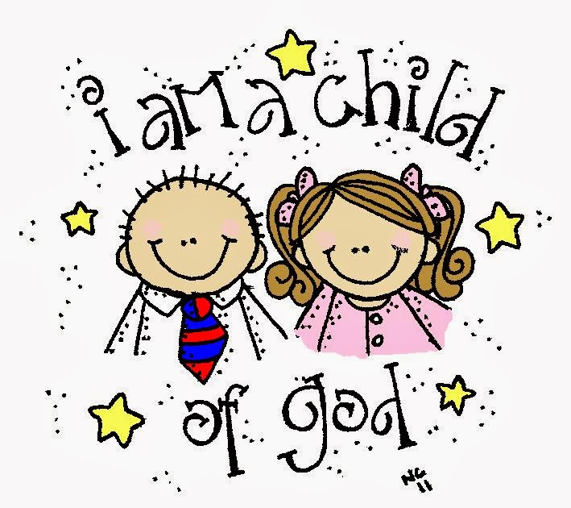

The Congregational Church
of
North Stonington, U.C.C.

89 Main Street
North Stonington, CT 06359
NoStoUCC@comcast.net
NoStoUCC.org

June 7, 2026
Celebrating Children and Youth

CHRISTIAN EDUCATION SUNDAY 10 a.m.
“As an Open and Affirming church:
We respect the worth and dignity of all persons who come into our church family regardless of race, age, marital standing, gender identity, economic status, mental or physical challenges, nationality or sexual orientation. We promise to support one another in our personal struggles, to understand and accept differences in one another, and pray to strengthen our love and acceptance.”

*indicates those who are able are invited to stand

WELCOME AND SHARING THE WORK OF THE CHURCH

YOUTH CHOIR Prelude
“Come and See the Works of the Lord” - Williams/Drennan

SILENT MEDITATION IN PREPARATION FOR WORSHIP

CALL TO WORSHIP from Psalm 34, The Message

*HYMN #84 This is The Day This is The Day

*PRAYER OF INVOCATION AND LORD’S PRAYER (debts, debtors)

God we do not always know what to do. Today we remember the question: What would Jesus do? When we are unsure about the future we need to ask, what would Jesus have done? If someone had fallen on the road, would he walk away? God help us to do what Jesus did so we can know how to do your will. And so we pray: Our Father…

*GLORIA PATRI (#759)
Glory to the Creator, the Christ, the Holy Spirit
Three in One; As it was in the beginning,
Is now and ever shall be, world without end. Amen, amen.

*PASSING OF THE PEACE (we offer a sign of Christ’s peace)
May the peace of Christ be with you.
And also with you.

YOUTH CHOIR ANTHEM “God is Calling Us” - Sleeth

SCRIPTURE LESSONS Selected Readings

ANTHEM “Praise and Exaltation” J. Martin/Angerman

THE MESSAGE

Moments of silence

*HYMN #524 This Little Light of Mine, v1, 2 This Joy
You may hold up Prayer Request for an usher to collect during hymn.

PRAYERS OF INTERCESSION Response: Lord, hear our prayer

CALL TO OFFERING

OFFERING OF OUR TITHES AND GIFTS

Offertory
“Let Us Break Bread Together” - Trad. Spiritual, arr. Manning
*DOXOLOGY
Praise God from Whom all blessings flow;
Praise God all creatures here below;
Praise God above, you heavenly host;
Creator, Christ, and Holy Ghost. Amen.

*PRAYER OF DEDICATION

SACRAMENT OF HOLY COMMUNION
Prayer of Confession
Merciful God, it is a healing balm to be able to come to you with our secret thoughts, our sad discouragements, and our noblest dreams. You listen. You forgive. You renew us! Surround us with your Spirit and grant us faith to perceive good arising despite evil, and to sense your immediate presence with us at all times. Hear now our personal prayer of confession...
Personal Confession
Words of Assurance
The power of the Holy Spirit breathes on us, and in us.
The Spirit blesses us with grace so we can start fresh.
God knows us and loves us. We are made new. Amen.
The Invitation and consecration
Sharing of the Bread and Cup
The Bread – we eat of the bread together.
The Cup – we partake individually as received.

gb*PRAYER OF THANKSGIVING
God, we thank you for words we taste, and bread we hear, and for the cup in which we drink metaphor and mystery, healing and haste, the gratitude of our spirits and a blessing on our lives. Amen

*HYMN #526 Siyahamba Siyahamba
Siyahamba kukhanyen kwenkos
Siyahamba kukhanyen kwenkos (repeat)
Siyahamba, hamba, Siyahamba (ooh)
Siyahamba kukhanyen kwenkos (2x)

We are marching in the light of God
We are marching in the light of God (repeat)
We are marching, marching – We are marching (ooh)
We are marching in the light of God

*BENEDICTION
*BENEDICTION RESPONSE (see insert)
Halle, halle, halle - luia Halle, halle, halle – luia
Halle, halle, halle – luia Halleluia, Halle - luia

Postlude “Sound the Loud Trumpets” - Lani Smit

Please exit quietly so those who wish to stay and listen may

We live-stream on Youtube and Facebook thru nostoucc.org

Welcome! Thank you for worshiping with us today! All children are welcome to attend church school. Please join us for conversation and Fair-Trade Coffee after worship in Hewitt Hall. Please sign our guest book at the entryway or fill out a pew card so we can get to know you.

Today we celebrate our Young People. The service will be led by our church school and special recognitions will take place. Sing along!
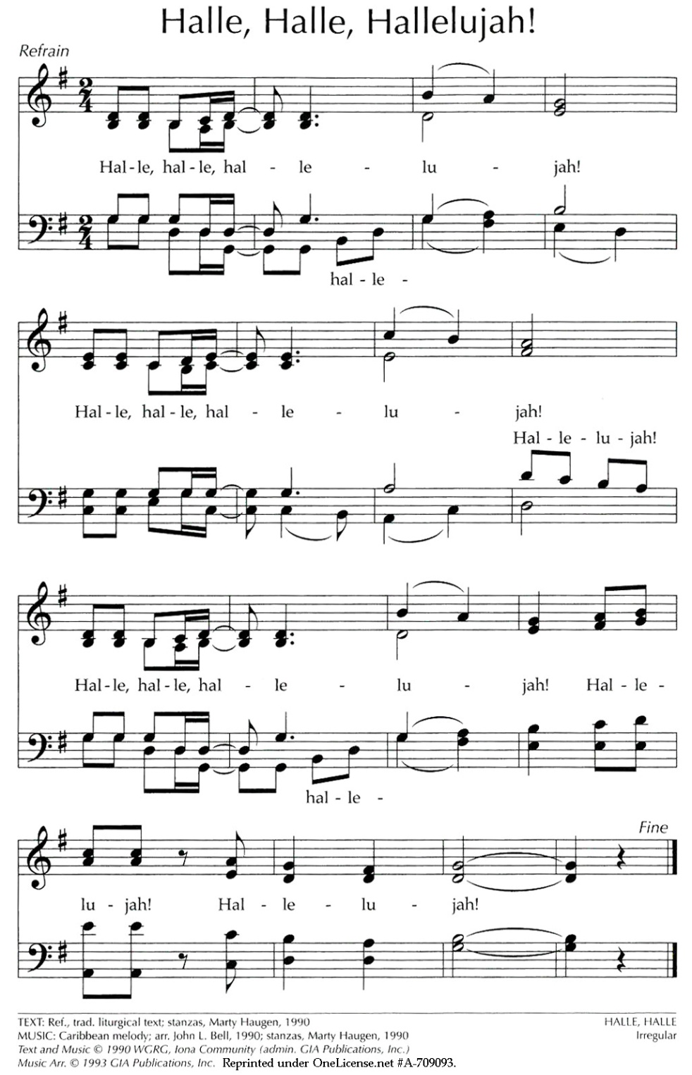

We light one white candle each Sunday to remember and pray for military and civilians serving our country and in harm’s way. The sunflowers are a symbol of prayer for Ukraine.

The flowers are given to the Glory of God by The Noonan family in honor of Joey Beauchemin’s 1st birthday.

The Steeple is lit this week by The Noonan family in honor of Joey Beauchemin’s 1st birthday.

Serving in Worship Julie Clow, deacon; Kevin Noonan, Gretchen Noonan; ushers; Patty Danley, Kathi Thaxton, communion.

We Pray For: Stephanie and Doug Murray; George McCullen; Aggie Terrill; Kevin Ames; Rev. Lee Ireland; Amy Foster; Debbie Janda; Kim Allard; David Allard; Mike Baker; Sue Pianka; Mary Stilli (Elizabeth Witter’s daughter); Ray Wells; Patty Danley; Robert Fox; Elizabeth Bouchard; Julie Evans; Kathi Thaxton; Marilyn Ware; Clare Whitney; Betsy Alvarez; Elizabeth Witter; Paul Ames; and Dave McCord.
Prayer requests remain for 6 weeks unless otherwise requested.

TOOLS TODAY Will be FOOD FOR TOMORROW
As we support Tools of Hope through Church World Service, we will be planting for a harvest of hope. Through CWS, families receive seeds and the tools needed to provide crops for the family and the community. Use the TOOL Giving Envelopes. Thank you.

HABITAT for HUMANITY of Eastern CT has a new home!
1 Bailey Circle, New London, CT 06329
It is in Hodges Square just off RT. 32 Route 32 and I 95.

Thursday: Pie-assembly a.m. & p.m.
Friday, 7 pm:, "Hallelujah for Handbells" - St. Luke's Lutheran Church, Rt.12 Gales Ferry. The music is presented by both adult and children's choirs. "Hallelujah for Handbells" is an annual handbell concert presented by the choirs of St. Luke's Lutheran Church in Gales Ferry, and others. This year "JuBellation", “Embellish", the "Grace Notes", and "The Belles" will be presenting.

This year's theme is "Creatures Large and Small". The pieces include:
All Creatures of Our God and King - Try Everything (Zootopia)
Alley Cat - Pink Panther - The Lion Sleeps Tonight
Yellow Bird - Feed the Birds - Under the Sea
All the Pretty Little Horses - Baby Elephant Walk
Crocodile Rock
Saturday, 11 am: Memorial service for Marge Misovich

ANTHEM Martin/Angerman
Rejoice with singing! Blow out the trumpet to Zion!
Sing praise to God for He is worthy.
Sing praise to God for He is holy, holy, holy.

Praise the Lord all ye nations. Praise the Lord all creation.
Praise ye the Lord and exalt His name forever.

Praise the Lord with the trumpet.
Praise the lord with the timbrel.
Praise ye the Lord with a joyful alleluia!

Praise the Lord, all ye people.
Praise the Lord in the temple.
Praise ye the Lord and exalt His name forever.

Praise the Lord with thanksgiving.
Praise the Lord in your living.
Praise ye the Lord with a joyful alleluia! Alleluia!

Praise to the Lord, O let all that is in me adore him.
All that hath life and breath, come now with praises before Him.
Let the amen sound from His people again.
Gladly forever, we adore Him.

God’s love endures for all generations.
His mercy reaches out to all of creation.
God’s grace is greater than the vastness of the sea.
His love will last eternally!

Praise the Lord, all ye people.
Praise the Lord in the temple.
Praise ye the Lord and exalt His name forever.
Praise the Lord with thanksgiving.
Praise ye the Lord with a joyful alleluia.
Sing alleluia! Sing alleluia!

All Hymns from the (NCH) New Century Hymnal; © 1995 The Pilgrim Press, have been granted permission for this one-time use. Permission to reprint, podcast,
and / or stream the music in this service obtained from ONE LICENSE with license #735340-A. All rights reserved.
7 June 2026 Youth Sunday
Remember the Sabbath by keeping it holy.” — Exodus 20:8
We are commanded to remember the Sabbath, not because God needs our remembrance, but because the Creator of the very cosmos knew humans needed a sacred pause.
We live in a world that seeks out and praises motion, yet our souls are shaped for stillness. Sabbath is not something we find, it is something we create-- a sacred pause inviting rest, reflection, and renewal.
In choosing rest, we resist the falsehood that we are what we produce. We shun the notion that we are what we do. And once we leave those thoughts behind we become open to who we are meant to be: present, whole, and held.
Sabbath is setting time apart. Time to be. Time to reflect. Time to think, and change our priorities for just a bit. And this, too, takes practice. Begin to seek out the spaces where you can find Sabbath. Not waiting for those spaces to evolve, but creating them with intentionality.
- Lori, at Yogadevotion
Global Ministries Prayers for the Philippines
Gracious and healing God, Holy Teacher, you show us how to have hope when the situation appears hopeless, and how to show mercy, especially for those seeking to do right. When resources are scarce, we pray that you provide enough. When burdens are heavy, it leads us to give thanks for those who help us bear them. When dreams seem distant, breathe new possibility into our lives. Teach us to recognize your presence not only in grand works, but in every faithful touch, every generous gift, and every life restored in hope. In your mercy and abiding love, hear our prayer. Amen.

Our Ministers: the congregation Susan G. Latourette, Pastor – 860-759-4231, pastorsuel@yahoo.com Michael G. Noonan, Director of Music
Margaret Leonard, Christian Education Coordinator Rosemary Kuemper, Church Secretary Charlotte Melia, Sexton
Office hours: Monday –Thursday, 9am - 1 pm 860-535-0379

