“Sing to the Lord; bless God’s name; tell of God’s salvation from day to day. - Psalm 96:2 (NRSV)
As I write this reflection, there’s a skunk in my bathroom and an odiferous dog in my laundry room. Last night dog found skunk, skunk sprayed dog, dog chased skunk into house, owner drove dog (not skunk) to emergency vet, then made a fruitless midnight search for hydrogen peroxide and baking soda. And it’s also my birthday.
I’d planned to start my new year with quiet time and coffee, followed by a walk with the dog. Now, I just want to growl my way into the year ahead.
Psalm 96 changes my tune. Day to day, the psalmist sings, “Sing to God, bless God’s name, tell of God’s salvation.” Not just on the good days, but every day. So, by the grace of God, I follow the ancient composer’s advice and start the morning with “My life flows on in endless song; above earth's lamentation, I hear the sweet tho far-off hymn that hails a new creation.”
With the smell of last night’s escapades wafting through the house (and no plan yet for getting the skunk out of the bathroom), the hymn’s promise of a new creation feels quite far off. Yet the hymn has already sustained my life and ministry for decades. This morning is no exception. -Talitha Arnold

Global Ministries Prayer for the Democratic Republic of Congo
We come before Your throne of grace with humble and repentant hearts on behalf of our nation. The crisis we face is not merely political or economic; it is a crisis of the spirit and of the soul.
Bind all Protestant families and Christian communities in unity so that we may stand as one light in the darkness. Restore our land, Lord. The Democratic Republic of Congo shall not die; it shall live and proclaim the works of the Lord. Keep Your Church faithful to its prophetic calling—to denounce evil without fear, to defend truth, and to act as peacemakers across every province. Grant us national unity and deliver our land from the hands of foreign exploitation, violence, and division. In the name of Jesus Christ, our Lord and Savior, Amen.

Our Ministers: the congregation Susan G. Latourette, Pastor – 860-759-4231, pastorsuel@yahoo.com Michael G. Noonan, Director of Music
Margaret Leonard, Christian Education Coordinator Rosemary Kuemper, Church Secretary Charlotte Melia, Sexton
Office hours: Monday –Thursday, 9am - 1 pm 860-535-0379

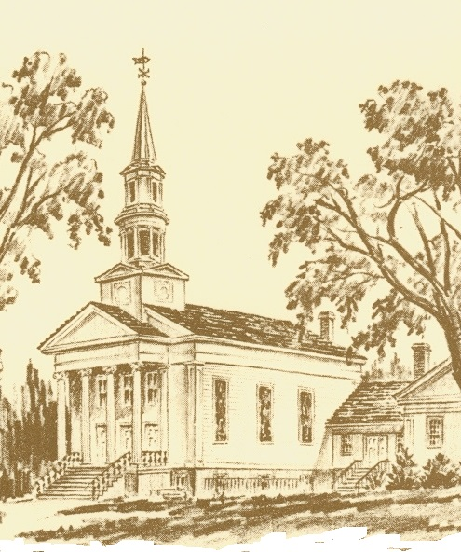

The Congregational Church
of
North Stonington, U.C.C.

89 Main Street
North Stonington, CT 06359
NoStoUCC@comcast.net
NoStoUCC.org

October 18, 2026

22nd SUNDAY OF PENTECOST 10 a.m.
We respect the worth and dignity of all persons who come into our church family regardless of race, age, marital standing, gender identity and expression, economic status, mental or physical challenges, nationality, or sexual orientation. We promise to support one another in our personal struggles, to understand and accept differences in one another, and pray to strengthen our love and acceptance.”
*indicates those who able are invited to stand

WELCOME AND SHARING THE WORK OF THE CHURCH

Handbell Prelude “Celebration” - Fred Gramann

SILENT MEDITATION IN PREPARATION FOR WORSHIP

*CALL TO WORSHIP
Praise the Lord; praise God, o my soul!
Let us praise God as long as we live.
Happy are those whose hope is in God, who labor in love…
Grace, and peace to all who worship God
whose care we know lifts us up and frees us.

*HYMN #566 Heaven and Earth, and Sea and Air Gott Sei Dank

PRAYER OF INVOCATION AND LORD’S PRAYER ((debts/debtors)
O God of all peoples, we gather in faith and hope to worship and praise you. You have fed us in ways we did not know and have supported us when we had no strength of our own. Turn us away from the world’s distractions. Bring us together to remember the good news of your healing love. May we experience your Spirit moving among us that can bring us joy. Hear us as we pray: Our Father…

*GLORIA PATRI (#759)
Glory to the Creator, the Christ, the Holy Spirit
Three in One; As it was in the beginning,
Is now and ever shall be, world without end. Amen, amen.

*PASSING OF THE PEACE (we offer a sign of Christ’s peace)
May the peace of Christ be with you.
And also with you.

TIME FOR CHILDREN
Children are invited to attend church school

SCRIPTURE LESSONS (NCH page 684) Psalm 96
(NT page 24) Matthew 22:15-22

SENIOR CHOIR ANTHEM
“Sing When the Spirit Says Sing” - arr. Jesse Vaughn

SERMON “Where is Your Treasure”

Moments of silence

HYMN #448 Take My Life, God Let it Be Vienna

OFFERING OF OUR TITHES AND GIFTS

Handbell Offertory “Kum Ba Yah” - .arr. John F. Wilson

*DOXOLOGY (#780)
Praise God from Whom all blessings flow;
Praise God all creatures here below;
Praise God above, you heavenly host;
Creator, Christ, and Holy Ghost. Amen.

*PRAYER OF DEDICATION

PRAYERS OF INTERCESSION Response: Lord, hear our prayer

*HYMN #563 We Cannot Own the Sunlit Sky Endless Song

*BENEDICTION
POSTLUDE “Postlude on Darwall’s 148th” - Charles Callahan

Please exit quietly so those who wish to stay and listen may

Cameras are in use - We live-stream on Youtube and Facebook

Welcome! Thank you for worshiping with us today! All children are welcome to attend church school. Please join us for conversation and Fair-Trade Coffee after worship in Hewitt Hall. Please sign our guest book at the entryway or a pew card so we can get to know you.

We light one white candle each Sunday to remember and pray for military and civilians serving our country and in harm’s way. The sunflowers are a symbol of prayer for Ukraine.

The flowers are given to the glory of God.

Serving in Worship Dave McCord, deacon; Kris and Joe Serwinski, ushers, Sherri Boldt, lay reader.

We Pray For: Stephanie and Doug Murray; George McCullen; John and Aggie Terrill; Kevin Ames; Rev. Lee Ireland; Amy Foster; Debbie Janda; Mike Baker; Sue Pianka; Mary Stilli (Elizabeth Witter’s daughter); Patty Danley; Robert Fox; Elizabeth Bouchard; Julie Evans; Marilyn Ware; Clare Whitney; Betsy Alvarez; Elizabeth Witter; Paul Ames; Dave McCord; Nancy Rockwell; Mark Ball; and George Haimbach. Prayer requests remain for 6 weeks unless otherwise requested.

Today: Proposed 2027 Budget Meeting
After Worship - Youth Choir
1 pm: CROP HUNGER WALK, Mystic
Wednesday, Noon: Women’s Connection “Lunch Bunch”
Brown Bag Lunch
Thursday: Pie-assembly a.m. & p.m.
5:00-5:40 pm : Youth Choir
6:00-7:00 pm: Senior Choir
7:15-8:30 pm: Handbell Choir

COMING EVENTS
November 10, 7 pm: Church Council
26: Office closed in observance of Thanksgiving.

SENIOR CHOIR ANTHEM
“Sing When the Spirit Says Sing” - arr. Jesse Vaughn

When the spirit tells me to pray,
Lord, I’ll pray
When the spirit tells me to preach,
When the Holy Spirit tells me to shout, I’m gonna shout, my Lord!
When the spirit says sing, Lord, I’ll sing, I will sing.

I'm gonna sing when the Spirit says sing,
I'm gonna sing when the Spirit says sing,
I'm gonna sing when the Spirit says sing,
And obey the Spirit of the Lord.

I’m gonna shout…..

Listen, listen, I’m gonna preach now, listen, listen, I’m gonna preach!

I’m gonna pray…..

I’m gonna sing…..

When the spirit tells me to pray,
Lord, I’ll pray
When the spirit tells me to preach,
When the Holy Spirit tells me to shout, I’m gonna shout, my Lord!

CALL FOR CHURCH MEETING

Notice is hereby given to all members of the Congregational Church of North Stonington, UCC, of a meeting to take place on Sunday, October 18, 2026, following worship.

The purpose of the meeting is to: -Hear and act on the Church Council’s proposed FY2027 budget, for planning and stewardship campaign purposes. The final FY2027 Budget will be voted on during the Church’s Annual Meeting held in January 2027
-Act on other said business to come before the congregation.

People may attend in person at church or via Zoom. A link will be posted on our website and emailed in the October Preview.

MISSION FOCUS FOR October: Neighbors In Need - United Church of Christ, supports ministries of justice and compassion, with one - third of the offering given to the Council for American Indian Ministries and the remaining two - thirds supporting UCC justice ministries. In 2025,
the Neighbors in Need Offering supported 26 grant recipients across the UCC who were engaged in service and advocacy projects.
All Hymns from the (NCH) New Century Hymnal; © 1995 The Pilgrim Press, have been granted permission for this one-time use. Permission to reprint, podcast, and / or stream the music in this service obtained from ONE LICENSE with license #735340-A. All rights reserved

